ONLINE EXAM

Project Report
On
Online Exam

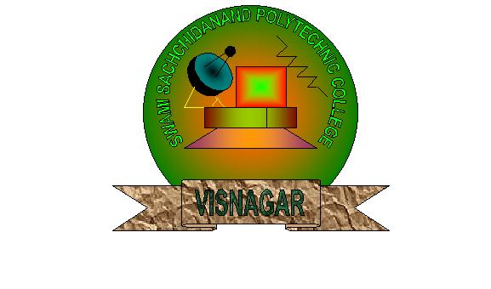

Diploma in Computer Engineering (6Th SEM)
2010

Internal Guide By: - Prepared By:-
Mr. Amit Gorvadiya. Patel Shruti
Patel Hiral
External Guide By: - Patel Naiya
Mr. Pankaj Patel Patel Kinjal

Submitted to
Department of Computer Engineering,
Swami Sachchidanand Polytechnic College
Visnagar-384315.

CERTIFICATE

This to certify that the following students of Swami Sachchidanand Polytechnic College pursuing Diploma in Computer Engineering from the semester 6th have satisfactorily completed their project work on “Online Exam System” within the college premises in the academic year 2010.

Registration No: - Entitled Project To:-
S152807044 Patel Shruti
S152807033 Patel Hiral
S152807038 Patel Naiya
S152807036 Patel Kinjal

Mr. Pankaj Patel Mr. Dharmesh Shah
Lecturer (C.E.Branch) H.O.D (Computer Dept)

ACKNOWLEDGEMENT

With a deep sense of gratitude and respect I would like to extend my heartiest thanks to all those who provided me immense help and guidance during in our 6th Semester.

I would like thanks Mr. Amit Gorvadiya for providing an opportunity for a creating a Online Exam System.

Mr. Amit Gorvadiya for providing a vision about the system, their patience and suggestions on improving our skill set through their constant guidance during this project. We have greatly benefited from their regular review and inspiration throughout the work.

Last but not the least I would like to mention here that I am greatly indebted to each and everybody who has been associated with my project at any stage but whose name dose not finds in this Acknowledgement.

COMPANY PROFILE

COMPANY PROFILE

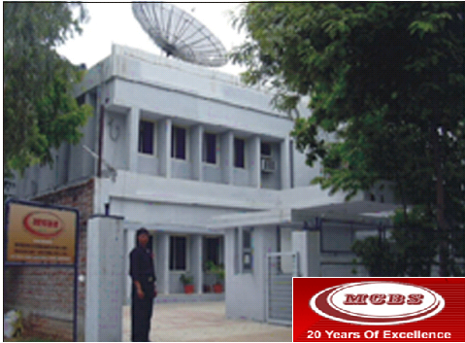

Modern Communication and Broadcast Systems Pvt. Ltd
SF-11 WING, MARADIA PLAZA, NEAR ASSOCIATE PETROL PUMP, C.G ROAD, AHMEDABAD- 380006
PHONE: 079 - 26465306, 26562821, 30020082. FAX: +91- 79- 2640107

FACTORY: B 138/139, GIDC ELECTRONICS ESTATE, SECTOR – 25, GANDHINAGAR - 382044
PHONE: 079 –23287369 FAX: +91 - 79 – 23287295
EMAIL: info@mcbsintl.com

ABOUT THE COMPANY
Modern Communication & Broadcast Systems Pvt. Ltd is popularly known as “MCBS” is headquartered in Ahmadabad, Gujarat, India Instituted in 1985 by Professionals and technocrats having Engineering experience of more than 20 years from India’s Pioneering Space Technology service of Communication and Broadcast Industry since past 20 years.
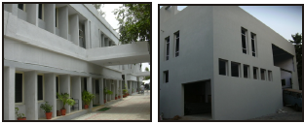

VISION:
Modern Communication and Broadcast Systems Pvt. Ltd (MCBS) would like emerge as a leading Indian manufacturer, Innovative Technology Solutions Provider system and system integrator for Broadband cable, Satellite and Wireless Systems.
MISSION:
Cost effective quality products & solutions using State of the art of Technology and innovations would be paramount in our work culture. Customer satisfaction and concerted efforts shall be key to our success, progress, and growth. MCBS will be committed to comply with the requirements and continually improve the effectiveness of quality management system to achieve the goals.
MCBS has successfully accomplished a large number of prestigious projects within the stipulated time frame and that has earned a company a very good name with its customers as well as suppliers. For more than 20 years of its successful operation, MCBS has steadily grown to its present size. Here are some of the highlights of its achievements. MCBS has achieved a distinction of being knowledge based company with immense experience in Communication & Broadcast field. It has achieved numerous milestones and made history by developing and introducing several technologies for the first time in India. These milestones have been achieved through its rigorous R & D efforts, systems engineering and well – knit system integrator approach.
MCBS key areas of activities are as follows:
- Manufacturing of Communication & Broadcast equipment.
- Turnkey projects and system integration.
- Marketing of Hi-Tech Communication projects.
- Technical support services.
THE ACHIEVEMENTS

MCBS has manufactured, supplied and installed the following major systems.
- 75000 DRS/TVRO terminals for TV networking & distance education.
- More than 15000 CATV head ends for 48-100 channels throughout India.
- More than 1000 sets of switching, distribution and processing equipment deployed in various TV transmission projects of Prasar Bharti.
- 12, 00, 000 DTH terminals including DTH antennas systems.
- More than 2, 00,000 amplifiers and millions of passives.
- MCBS has manufactured numerous custom built products for various customers in India and abroad.
- MCBS has accomplished more than 150 projects for key customers and organizations in various Noncom field listed below:
- 50 projects in Digital Video Broadcast (DVB) field for ISRO, Defense, VSNL, Dot & others.
- 75 projects in TV networking & distance education for various Governments Govt. of MP, AP, Orissa, Gujarat, Himachal Pradesh, Karnataka and the Prasar Bharati and others.
- 50 projects for CCTV and Security systems for various Industries.
- 3 CATV Super Head end for in cable net, Hath way and RPG Netcom.
- 25 Digital CATV projects for Hath way in Mumbai, Chennai & New Delhi, Reliance (Mumbai and Jamnagar) in association with Scientific- Atlanta and other companies.
- Head end for SAHARA city and fiber network for Tata Telecom.
- 25 MCBS Digital Cable Head ends to MSoS.
- MCBS has designed and developed set-top box for satellite, cable & terminal applications under a project of the Ministry of Information Technology for the first time in India.

MCBS CONTRIBUTIONS—COMMUNICATION AND BROADCAST INDUSTRY
- It has introduced SATCOM Antenna systems for S & C band in the early stages (1988). It has thus installed based of more than 75,000 DRS, TVRO, ROT (18’, 12’, 16’, and 24’) in the market. These have been used for CATV operation, Distance Learning and satellite Channel reception.
- It has manufactured CATV products in the very early stages of CATV industry (1984 onwards) and sold more than a million pieces of Amplifiers & Passives. It has a track record of manufacturing and installing more than 15000 CATV Head ends (Analogue) for Cable TV operators in India.
- MCBS has introduced Digital Compression Technology in the year 1995 and has established many SATCOM uplink projects for ISRO, VSNL for international gateways.
- MCBS has introduced DTH terminals for DD direct plus for Prasar Bharati and sold more than 0.5 million units of these to various customers in India.
- MCBS has introduced wireless IP-CCTV for Jail project and established 60 systems in major Jails in Gujarat.
- MCBS has designed and developed Video-Audio equipments technology for various LPT & HPT Projects of Prasar Bharati. It has supplied more than 1000 such systems.
- MCBS has introduced digital CATV Head ends technology and sold more than 25 such Head ends and more than 250 Encoders in a short span of 1 year.
- MCBS has designed and developed Set Top Box technology for cable, satellite and terrestrial application in the year 2002-03 under financial assistance of ministry of IT.
MCBS R&D DIVISION
- The success of MCBS lies in its R & D activities. MCBS manufacturing a large range of products that are the out comes of its R & D efforts. This in house R & D unit of MCBS is approved and recognized by the Department of Scientific and Industrial Research (DSIR), Ministry of Science and Technology Govt. of India. MCBS has set up an R&D Centre for “Digital Compression Technology Products.
- MCBS has been selected and chosen by the Department of Electronics, Ministry of I.T. for Research and Develop of Set Top Boxes for DVB-S, DVB-T & DVB-C applications. MCBS is now concentrating on other advanced technologies for future applications like Fiber Optics equipment, Advanced Video Audio Products, Digital Compression products, TV + IP on DTH.
SUPPORTS FOR FOREIGN PRINCIPAL COMPANIES
- Thomson Grass Valley, France.
- NEWTEC Cy., Belgium.
- FOXCOM, Israel.
- ADI Video technologies, Israel.
- International Data casting, Canada.
- Prodys, Spain.

MCBS SERVICES
SUPPORT DIVISION PROVIDES FOLLOWING SERVICES
- Installation & Commissioning.
- Maintenance Preventive and Fault repairs & AMC.
- Testing & Measurement of equipments and systems.
- After sales support.
- Consultancy Services for setting up projects.

ABOUT NICIT

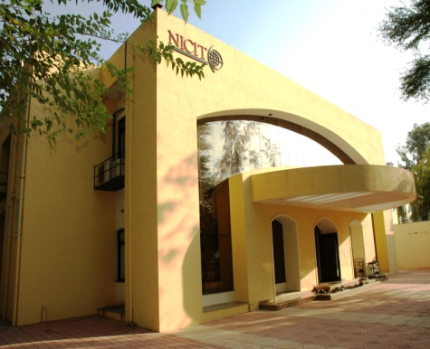
THE NATIONAL INSTITUTE OF COMMUNICATION AND INFORMATION TECHNOLOGY (NICIT) has been established with an objective to create a knowledge base in communication and its various applications. The institute is one of its kind, with emphasis on “hands –on-training” to support theoretical aspects of Communication & IT. The institute caters to the industry demands hitherto unexplored, and thus benefit manufacturing units, entrepreneur, system designers, operators, service maintenance engineers, Institute/bodies in the field of communication & information technology etc. Users at the grassroots level will also benefits from the NICIT programmes.
NICIT has also tie-up with Modern Communication and Broadcast Systems Ltd. (MCBS), a leading Indian company pioneer in the field of communication, broadcasting and information technology for training on technical aspects.
NICIT has also tied up with many Industries and Organizations of repute for organizing in- plant training & project work in various engineering disciplines.
Today’s fast growing world, communication has become an integral part of human life. The field of communication & information technology in particular has witnessed a phenomenal growth with multitude of exhilarating technologies - Internet, e-commerce, voice, image & data convergence, internet telephony, wireless applications, broadband, DTH & multimedia technologies. The development of ICT industry at such a rapid pace all over the world, demands highly trained and talented manpower. Consequently, there is a need to establish a hi-tech institute to augment the knowledge of people in communication and information technology

INTRODUCTION TO IMPLANT TRAINING & PROJECTS
Implant training is an essential and integral part of M.E/B.E degree and diploma courses /curriculum of various universities and educational institutions. Implant training and project work is carried out in various R & D / industrial / operational organizations. This training is generally a practical work / project work followed by a report / thesis submission to the authorities. Students are deputed to various industrial / research organization based on various subjects of interest allotted by their respective institutions. This practical training and project work helps students to understand industrial and corporate environment.

SALIENT BENEFITS
It acts as a bridge between academic institutions and industrial organizations for students who will be pursuing their professional careers. Students are exposed to practical work which helps them building confidence level and provide job opportunities. Project work & report remains an evidence of practical ability of one’s performance. This work enhances their ability for jobs and opens a gateway to the outside world for pursuing future careers.

IMPLANT TRAINING AT NICIT
Practical project work and implant training are of vital importance in emerging technology areas. As most colleges and institutes do not have facilities to meet practical training needs. NICIT has designed special programs for Implant Training for engineering & diploma students.
ADDITIONAL FOCUS AT NICIT
In addition to project work, there is an emphasis on “Academics” and “Additional Focus” at NICIT. Additional focus covers, soft skills such as communication skills, personality development and managerial skills. For a bright career, knowledge base is not enough; you have to focus on some special aspects which make your knowledge base more worthy and appreciable. These skills include personal skills, human skills and managerial skills. These skills actually decide your success in both personal and professional life. It also helps you to improve your job performance and quality of work and to rise up to managerial position and in building up a successful team. Knowledge and attaining of these skills can lead one to a successful professional career.

INDEX
Sr.No | Topics |  |  | Page No
1. | Project Profile
 | 1.1 |  | Overview
 | 1.2 |  | Need For The System
 | 1.3 |  | System Definition
 | 1.4 |  | Feasibility Study
2. | Software & Hardware Requirement
3. | System Analysis
 | 3.1 Problem Definition
 | 3.2 Rick Analysis
 | 3.3 Process Model
4. | System Design
 | 4.1 |  | Data Dictionary
 | 4.2 |  | UML Diagram
 | 4.3 |  | Screen Layout
5. | Project Scheduling
6. | System Testing
 | 6.1 | Testing Principle
 | 6.2 | Testability
 | 6.3 | Model of Testing
 | 6.4 | Testing Strategy
7. | Future Enhancement
8. | Summary
9. | Bibliography

